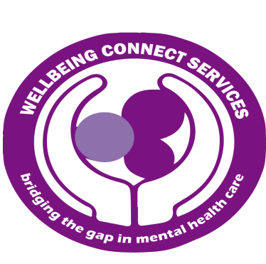
STANDING ORDER FORM
Godwin Obichukwu Legacy Fund in support of Wellbeing Connect Services.

We invite all friends, family and supporters of Godwin Obichukwu to donate in support of his charity (Wellbeing Connect Services).

Complete clearly, in black ink and BLOCK CAPITALS.

Title: Forename: Surname:
Address:
Postcode:
Tel: Mobile: Email:

Personal Details

I would like to make a regular donation via Standing Order of:
£5 £10 £20 £50 Other m

One off donation Monthly donation Quarterly donation Yearly donation
Please debit the above from my account on or around the (tick)
1st 15th 28th of the month starting (month) (year)

Instruction to your bank or building society.
Name and full address of your bank/building society
To: The Manager

(Name of bank/building society)  Address: | Signature(s  Date / /
Postcode:
Name(s) of account holder(s):

Account No:

Branch sort code:

And thereafter the same sum instalments to Wellbeing Connect Services until further notice
SORT CODE: 20-53-00 ACCOUNT NO: 40945935 BANK NAME: BARCLAYS BANK PLC

